**Task 1: Point 2D**

Point2D

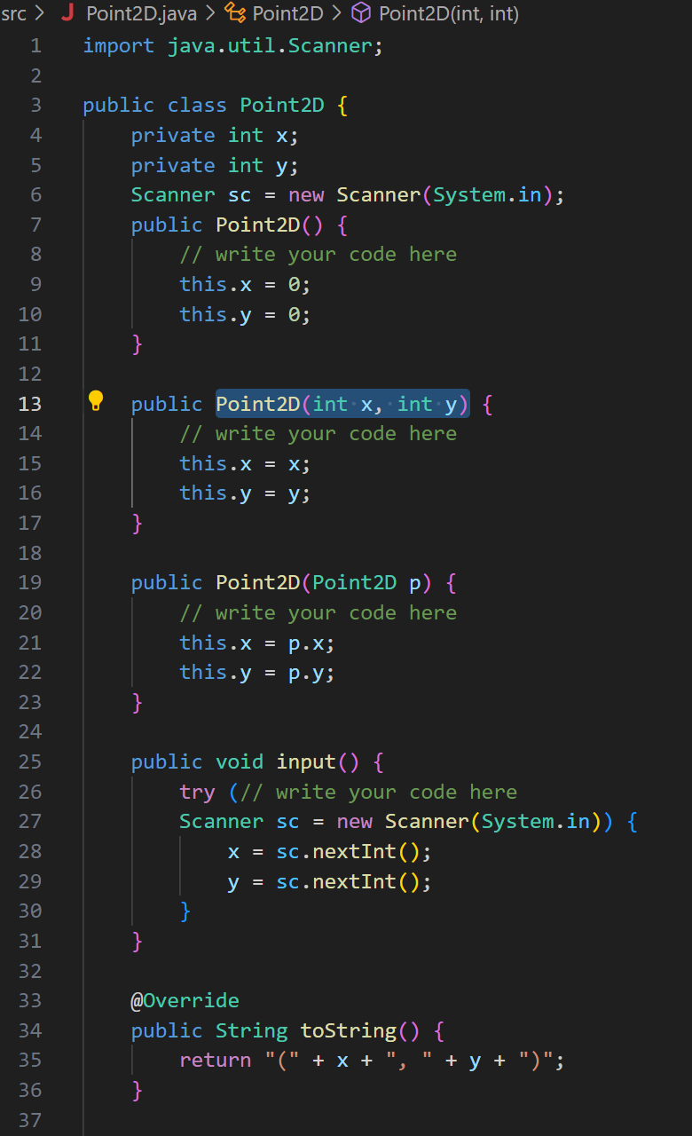

TestingPoint2D

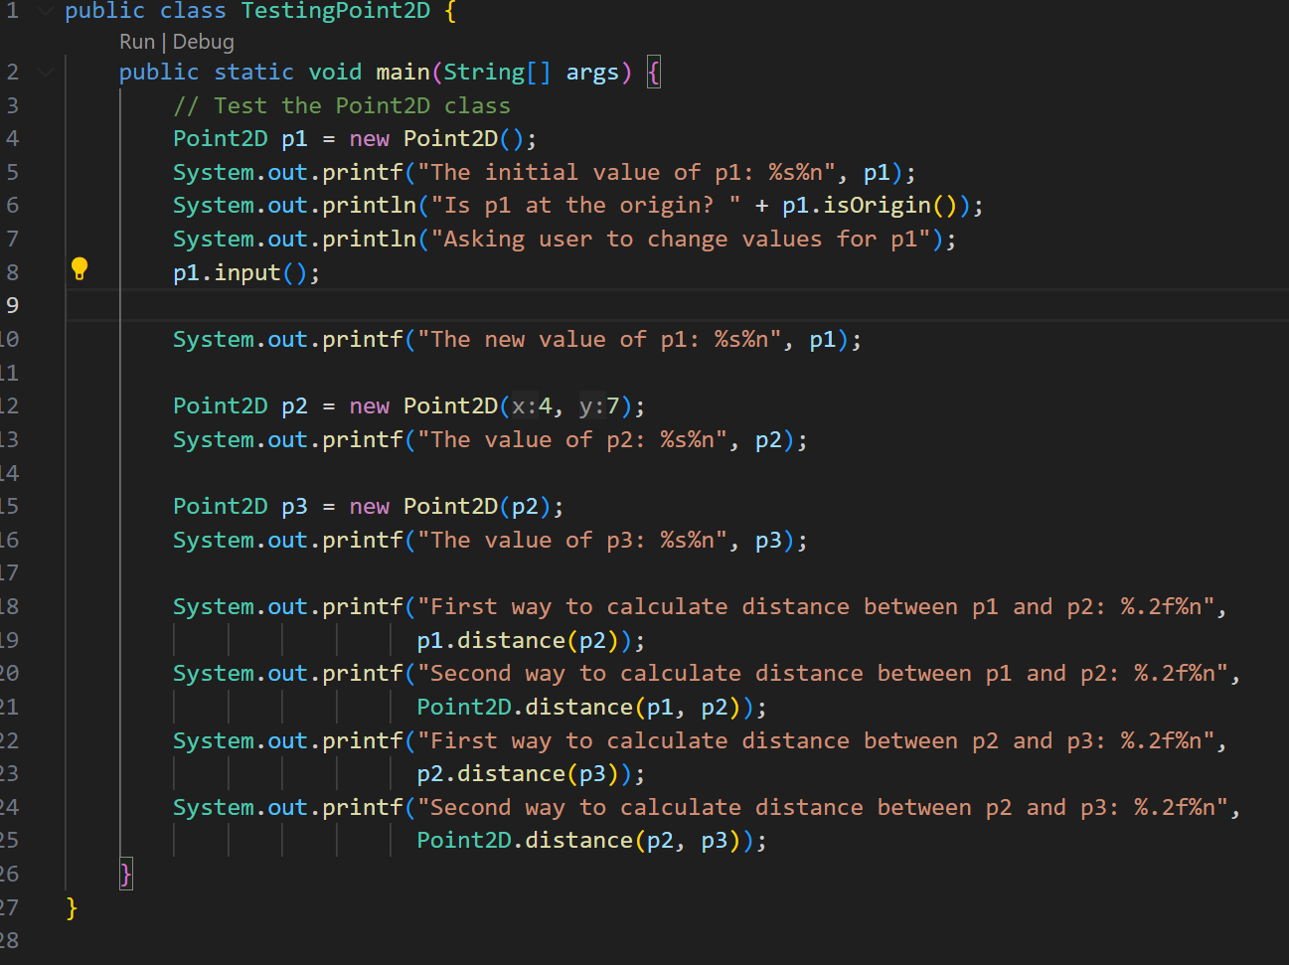

**Output**

**UML**

**Task 2: Rectangle verification**

Triangle

Point2D

TestTriangle

Output

UML

**Task 3: Inheritance for Student and Staff**

**Person**

**Student**

**Staff**

**TestInheritance**

**Output**

**UML**

**Task 4: Particle Behaviour in Box Simulation**

**Box**

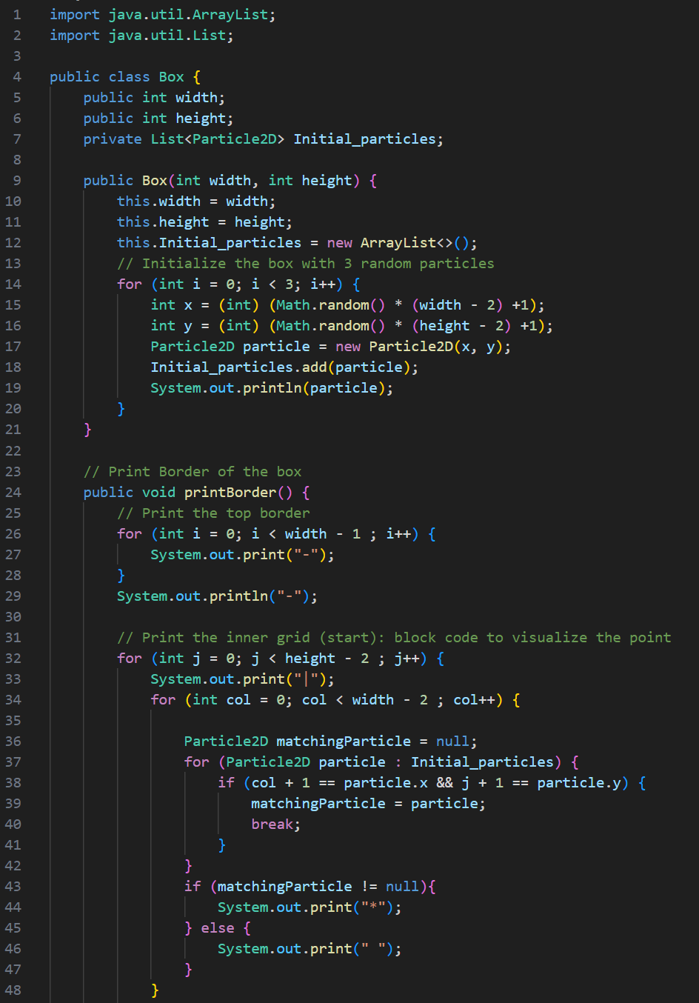**

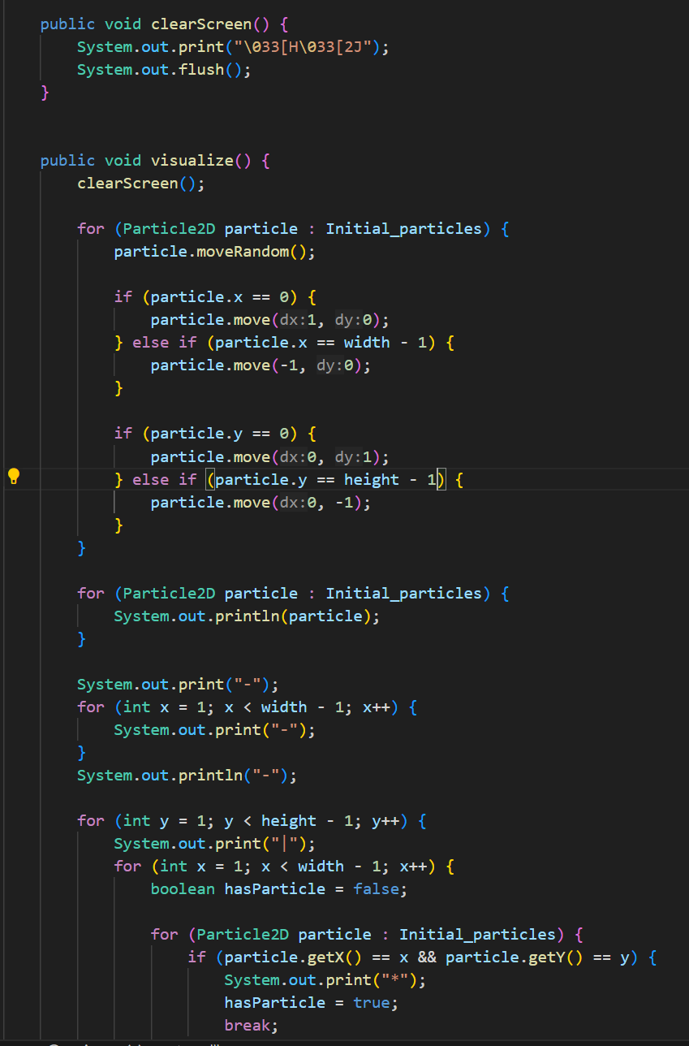 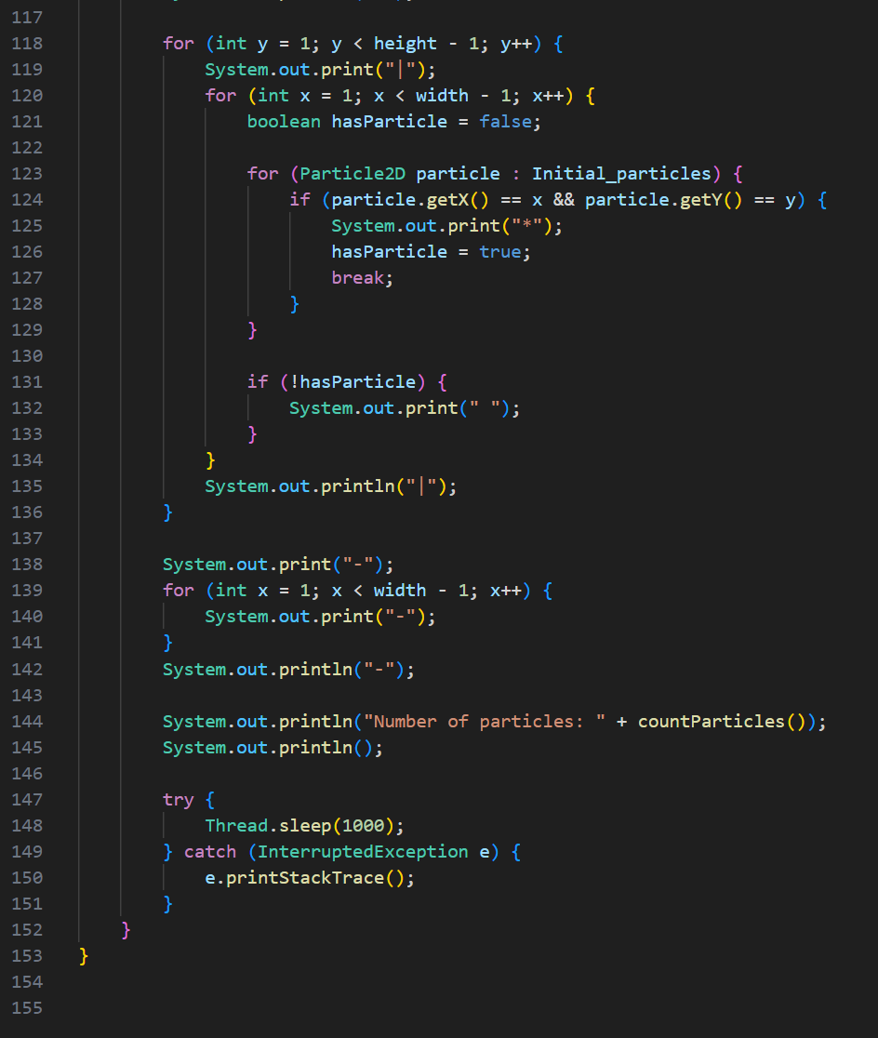

**Particlle2D**

**TestBehaviour**

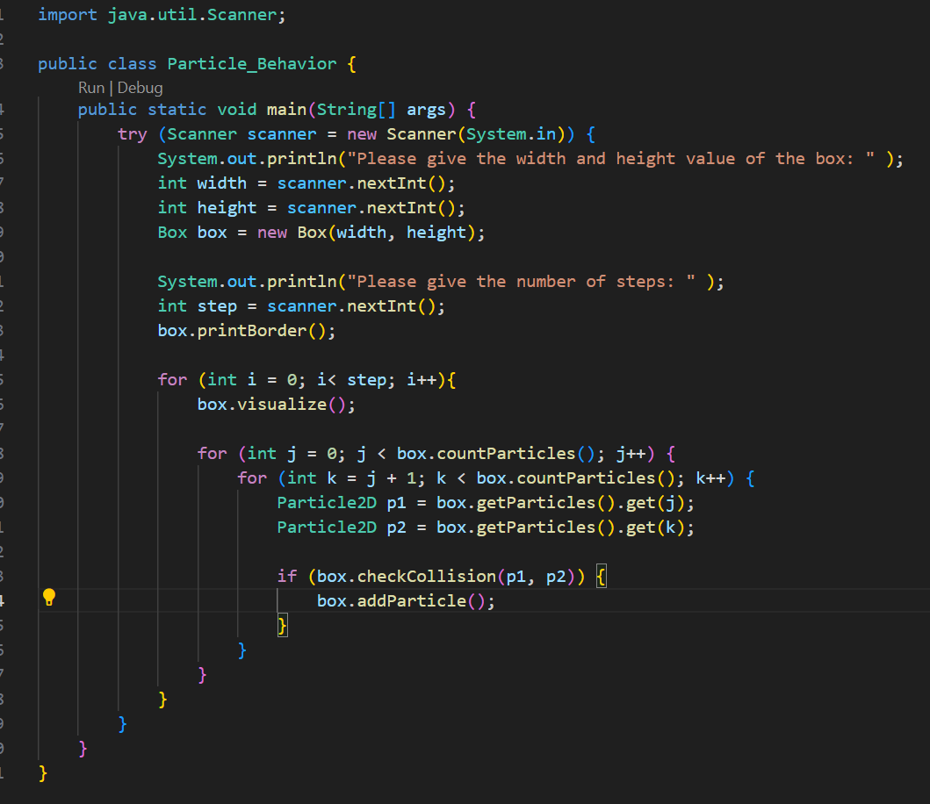

**Output**

**UML**

